Answer 8
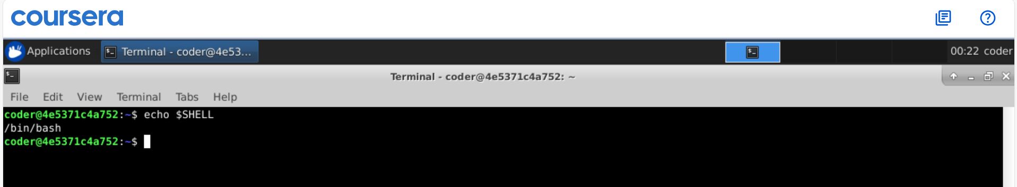
Explanation: $SHELL will give the name of shell in use and echo will show it on the screen.

